Controlling DC Motors with Arduino | Arduino L298N Tutorial
In this tutorial, you are going to learn about Arduino L298N Motor driver module interfacing. The L298N module has a very famous L298 Motor driver IC which is the main part of this module. This module uses the PWM method to control the speed of DC motors.

Specifications of L298N Motor Driver
The module will allow you to control the speed and direction of two DC motors.
It can control motors which operates between 5 to 35V and up to 2A.
The module has an onboard regulator which helps in giving the output of 5V.
The module can be powered from 5 to 35V from Arduino or external power supply. It is recommended to always use the external voltage supply.
It is inexpensive and perfect for robotic projects.

Pin out of L298N Motor Driver
Motor A: This terminal block will give the output for the first motor.
12V Jumper: Keep this jumper in place if your supply voltage is less than 12V and the 5V power pin will give you the output of 5V. If the supply voltage is greater than 12V, then remove this jumper and give the 5V supply to the 5V power pin so that the L298 Dual H Bridge IC can work properly.
Power Pins: Give the supply voltage from 5 to 35V at the 12V pin and ground. If your supply voltage is greater than 12, then make sure to remove the 12V jumper. 5V pin will act as Output if the Vs will be less than 12V and 5V pin will act as Input if the Vs will be greater than 12V.
Enable Pins: Remove the jumpers on the Enable A and Enable B if you want to control the speed of DC motors and connect these to PWM pins of Arduino. If you want to control the stepper motor with L298N, then keep the jumper on Enable A and Enable B. Keeping the jumper on these pins means that the these pins will be High.
Logic Pins: Connect the Logic pins to any digital pins of Arduino. These will help in controlling the rotation and speed of DC motors.
Motor B: This terminal block will give the output for the second motor.
5V linear Regulator: This will step down the supply voltage to 5V and will give the output at the 5V pin.
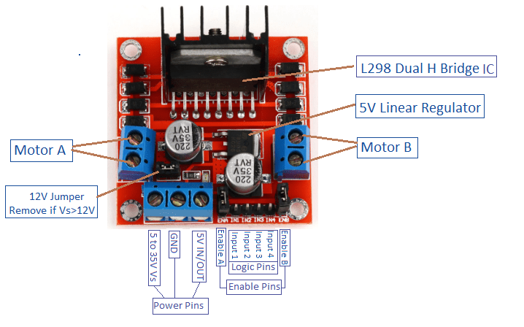

Components required for this Tutorial
The components required for this tutorial are as follows
- Arduino
- L298N Motor Driver Module
- 2 X DC Motors
- Joystick Module
- 12V Battery

Controlling the DC Motors using the L298N Motor Driver
The circuit diagram for connecting the L298N motor driver module with the Arduino is shown below. Make the connections as follows
L298N | Arduino | 5 to 12V battery/Power Supply
ENA | Pin 11
IN1 | Pin 9
IN2 | Pin 8
IN3 | Pin 7
IN4 | Pin 6
ENB | Pin 10
12V |  | 5 to 12V power supply or battery
GND | GND | Negative of power supply or battery
In last, connect the two dc motors at the two sides of L298N
Then connect the Joystick module with the Arduino as follows
Joystick Module | Arduino
VCC | 5V
VER | A1
HOR | A0
GND | GND
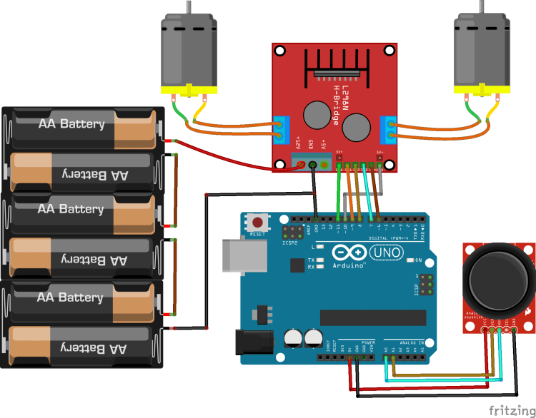

The code

- //Joystick Pins
- int x_key = A0;
- int y_key = A1;
- int x_pos;
- int y_pos;

- //Motor Pins
- int EN_A = 11; //Enable pin for first motor
- int IN1 = 9; //control pin for first motor
- int IN2 = 8; //control pin for first motor
- int IN3 = 7; //control pin for second motor
- int IN4 = 6; //control pin for second motor
- int EN_B = 10; //Enable pin for second motor
- //Initializing variables to store data
- int motor_speed;
- int motor_speed1;

- void setup ( ) {
- Serial.begin (9600); //Starting the serial communication at 9600 baud rate
- //Initializing the motor pins as output
- pinMode(EN_A, OUTPUT);
- pinMode(IN1, OUTPUT);
- pinMode(IN2, OUTPUT);
- pinMode(IN3, OUTPUT);
- pinMode(IN4, OUTPUT);
- pinMode(EN_B, OUTPUT);

- //Initializng the joystick pins as input
- pinMode (x_key, INPUT) ;
- pinMode (y_key, INPUT) ;
- }

- void loop () {
- x_pos = analogRead (x_key) ; //Reading the horizontal movement value
- y_pos = analogRead (y_key) ; //Reading the vertical movement value

- if (x_pos < 400){ //Rotating the left motor in clockwise direction
- motor_speed = map(x_pos, 400, 0, 0, 255); //Mapping the values to 0-255 to move the motor
- digitalWrite(IN1, LOW);
- digitalWrite(IN2, HIGH);
- analogWrite(EN_A, motor_speed);
- }

- else if (x_pos>400 && x_pos <600){ //Motors will not move when the joystick will be at center
- digitalWrite(IN1, LOW);
- digitalWrite(IN2, LOW);
- }

- else if (x_pos > 600){ //Rotating the left motor in anticlockwise direction
- motor_speed = map(x_pos, 600, 1023, 0, 255);
- digitalWrite(IN1, HIGH);
- digitalWrite(IN2, LOW);
- analogWrite(EN_A, motor_speed);
- }

- if (y_pos < 400){ //Rotating the right motor in clockwise direction
- motor_speed1 = map(y_pos, 400, 0, 0, 255);
- digitalWrite(IN3, LOW);
- digitalWrite(IN4, HIGH);
- analogWrite(EN_B, motor_speed1);
- }

- else if (y_pos>400 && y_pos <600){ //Motors will not move when the joystick will be at center
- digitalWrite(IN3, LOW);
- digitalWrite(IN4, LOW);
- }

- else if (y_pos > 600){ //Rotating the right motor in anticlockwise direction
- motor_speed1 = map(y_pos, 600, 1023, 0, 255);
- digitalWrite(IN3, HIGH);
- digitalWrite(IN4, LOW);
- analogWrite(EN_B, motor_speed1);
- }
- }

